Note Catcher: IEP Meeting Follow-Up
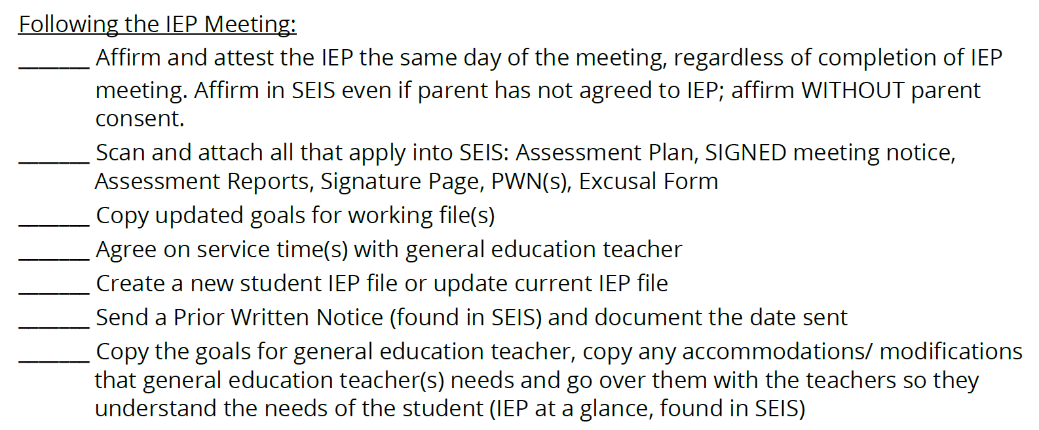
IEP Meeting Follow-Up
What processes will you need to develop in order to ensure these steps are completed with fidelity?

Who will you need to collaborate with to develop this process?

