Note Catcher: Module 1 Webinar- Introduction to the Thread of Educational Benefit: IEP Planning, Assessment and Communication
Thread of Educational Benefit
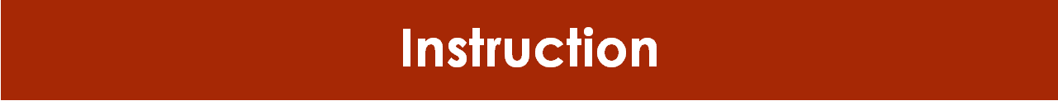
Standards:
Assessment:

Present Levels:

Identify Needs:

Goals and Objectives:

Services:

Progress:

Other Notes:

Standards: Where Instruction Begins
Standards as the Learning Target:

School-wide Foundational Supports:

When Standards are Not Enough
SST Process:

Assessment:

Other Notes:

The Role of Case Manager
Responsibilities:

Cornerstones to Communication:
H:

A:
I:
L:

Other Notes:

