Day 1 Workshop: Note Catcher
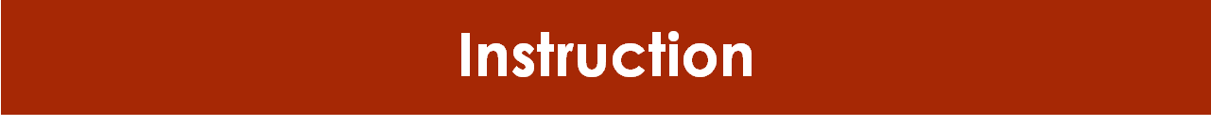

Activity 1: Student Profile
Independently review Jessica Day’s student profile and take notes below.
Key Ideas
Wonderings

Activity 2: IEP Team Communication
Take notes as you watch the TED Talk “How to speak so That Other People Will Listen”.

What are the 7 Deadly Sins of Communication?
What is HAIL? And how can you use this strategy to communicate effectively?

IEP Meeting Planning
As you review the IEP/Triennial IEP Planning document fill in the below prompts to guide small group discussion.

Key Ideas
Wonderings?

